Title: Welcoming Students
With a Visual Impairment/Blindness
To Your School
October 18, 2024

Day Five/Friday October 18: Welcoming Students To Your School Who are Visually Impaired/Blind/DeafBlind
This day supports all educators working with a new student to your school who has a visual impairment. How to procure equipment, where to get braille materials, how to empower your student, how to support the staff-everything you need to know, we cover it on this day!
Registration and ADA requests closes October 1, 2024. See you this Fall!

WELCOME

8:30 Welcome, Details & Introductions

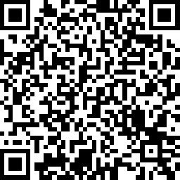Pre-test: https://rb.gy/ft8e8 | 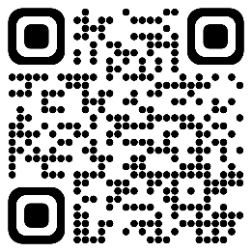  LiveBinder access  https://www.livebinders.com/b/2538630

9:00 Four Things Your Student Wants You to Know
Types of Vision loss

Vision simulation #1

Field Loss

Vision simulation #2
Legal Blindness

Visual processing/Cortical Vision Impairment (CVI)

The 411 on Glasses
National Stats

10:45 BREAK

PROGRAMMING FOR YOUR STUDENT(S)

11:00 Let’s Talk About Your Student

Implications of Vision Impairment

Vision simulation #3

What do WE need to do or not do?
Vision Professionals

Simulation #4
Educational Materials, Accommodations and Modifications
Programming for Students with VI/B
Expanded Core Curriculum
About large print and optical devices

12:00 LUNCH

ADAPTATIONS AND THE ENVIRONMENT

1:00 Computer Adaptations for iOS, Chrome, PCs
Basics of Braille/Where to learn Braille online
Adapting the Classroom Environment
Auditory Factors

2:00-2:15 Break

DEMONSTRATIONS AND PRODUCT DEMOS
2:30 Orientation & Mobility/Human Guide
Web Page Resources/LiveBinder/Folder Contents

3:30 Post Test & Evaluation (win some swag!)

POST TEST https://rb.gy/ir4y4  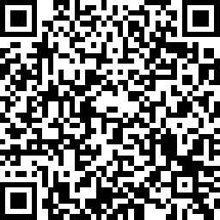 | EVALUATION https://rb.gy/oxwwk  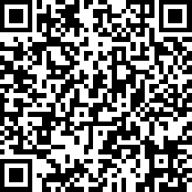

THANK YOU SO MUCH FOR COMING!

